# *Utility process - detailed architecture overview*

[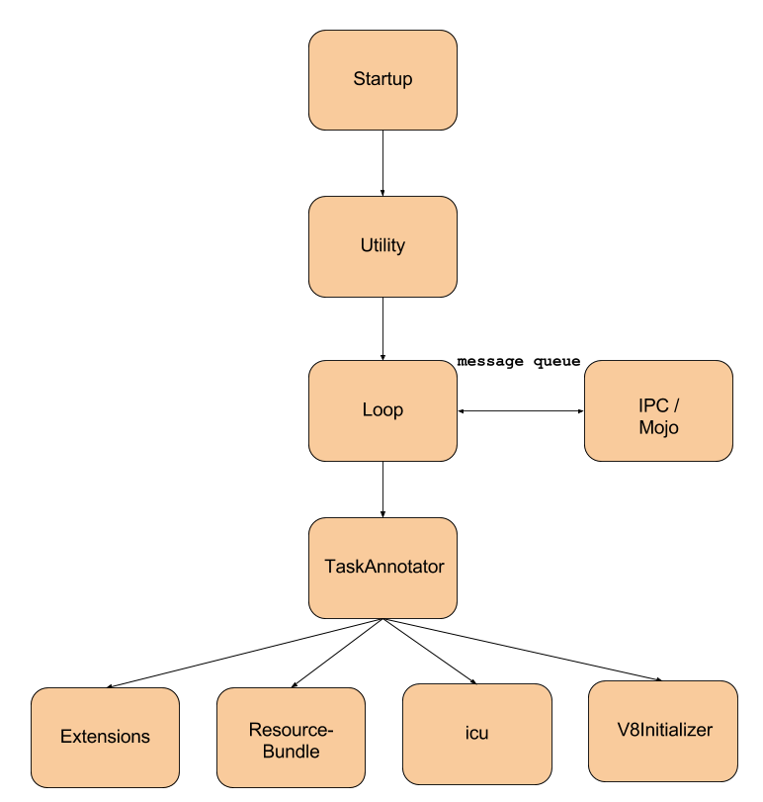](https://docs.google.com/drawings/d/14uUF0I9ckGi_apywWS7DNEC-9eV9AficoSeovxyNX18/edit)

* **Startup**
  + the entry point for the Utility process
* **Utility**
  + utility box represents the Utility Main
* **Loop**
  + MainMessageLoop
    - is used to process events for a particular thread
    - puts the incoming messages, tasks to a queue
    - pops a task from the queue and starts it
    - strong relationship with the IPC communication framework
    - has task reentrancy protection
      * second task cannot be started until first task finishes
* **IPC / Mojo**
  + framework which is used for inter-process communication
  + connects directly to the MainMessageLoop
  + provides communication channels through which the messages can be sent
  + message creating, sending and receiving
  + asynchronous message handling
* **Extensions**
  + ExtensionsHandler
    - dispatches IPCs for Chrome extensions utility messages
  + UtilityHandler
    - a handler for extensions-related IPC from within utility processes
  + unpack extensions
    - extensions::Unpacker
      * this class unpacks an extension
      * it is designed to be used in a sandboxed child process
      * various bits of the extension gets parsed, then it is reported back to the browser process, who then transcodes the pre-parsed bits and writes them back out to disk for later use
* **ResourceBundle**
  + initialize the ResourceBundle for this process
  + returns the language selected
* **icu**
  + initialize icu
    - create default TimeZone
* **V8Initializer**
  + initialize V8
    - load V8 natives from user provided platform file descriptors
    - without the natives the startup cannot continue

Sources:

<https://code.google.com/p/chromium/codesearch#chromium/src/base/message_loop/message_loop.h>

<https://code.google.com/p/chromium/codesearch#chromium/src/gin/v8_initializer.h&q=v8_initializer.h&sq=package:chromium&l=1>

<https://code.google.com/p/chromium/codesearch#chromium/src/ui/base/resource/resource_bundle.h&q=resource_bundle.h&sq=package:chromium&l=1>

<https://code.google.com/p/chromium/codesearch#chromium/src/chrome/utility/extensions/extensions_handler.h&q=extensions_handler.h&sq=package:chromium&l=1>

<https://code.google.com/p/chromium/codesearch#chromium/src/extensions/utility/utility_handler.h&q=utility_handler.h&sq=package:chromium&l=1>

<https://code.google.com/p/chromium/codesearch#chromium/src/extensions/utility/unpacker.h&q=unpacker.h&sq=package:chromium&l=1>